**Task 1**

INCLUDE Irvine32.inc

.code

main PROC

mov ax, 25

mov bx, 15

mov cx, 5

mov dx, 2

add ax,cx

sub bx,dx

mov al, 25

mov bl, 15

mov cl, 5

mov dl, 2

add al,cl

sub bl,dl

mov ah, 25

mov bh, 15

mov ch, 5

mov dh, 2

add ah,ch

sub bh,dh

call DumpRegs

exit

main ENDP

END main

**The numbers shown in red are the ones that have just changed because of the last instruction.**

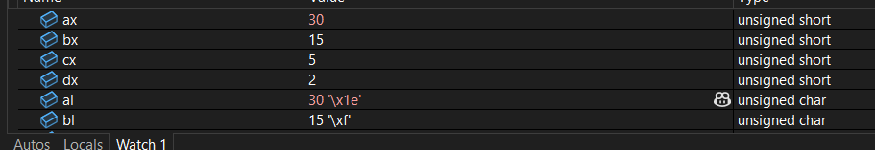

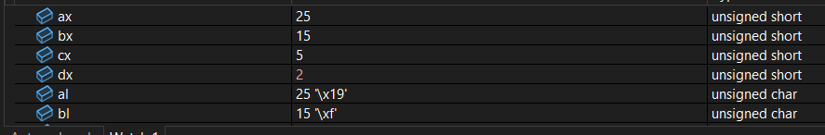

Cx is changing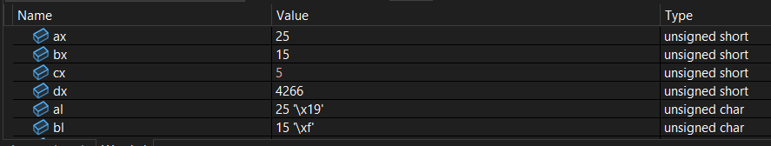

Bx and bl is changing

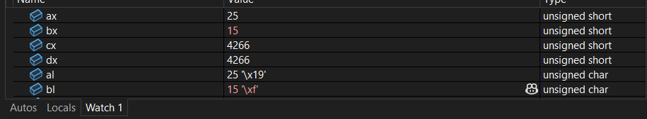

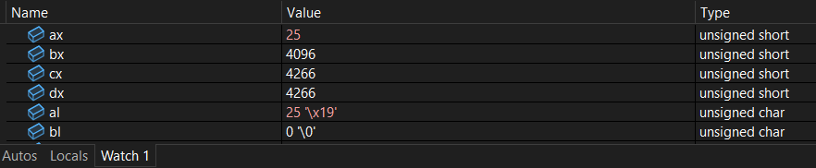

Result

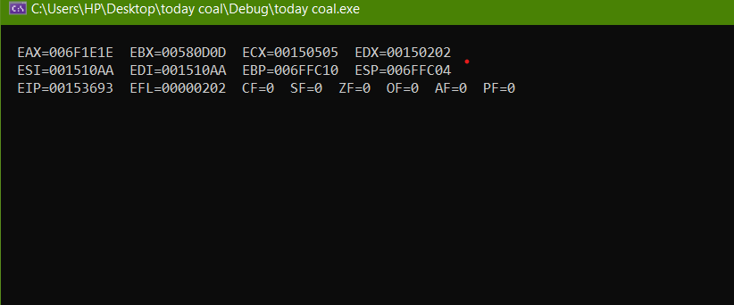

**Task 2**

INCLUDE Irvine32.inc

.code

main PROC

mov cx, 2593

mov dx, 2534

add cx,dx

mov cl, 93

mov dl, 34

add cl, dl

mov ch, 93

mov dh, 34

add ch, dh

call DumpRegs

exit

main ENDP

END main

**The numbers shown in red are the ones that have just changed because of the last instruction.**

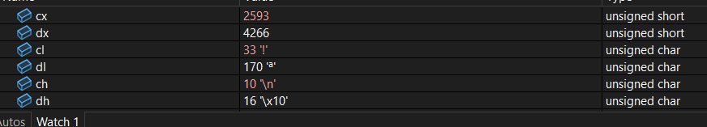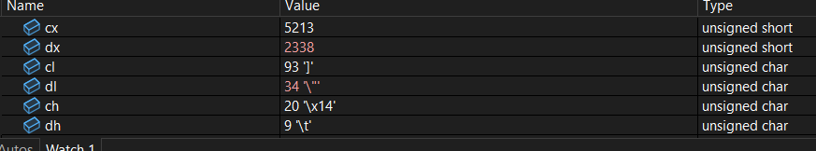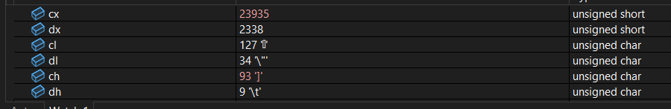

**RESULT**

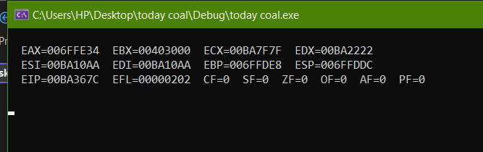

**Task 3**

INCLUDE Irvine32.inc

.code

main PROC

mov cx, 2025

mov dx, 2008

add cx,dx

mov cl, 20

mov dl, 7

sub cl, dl

mov ch, 20

mov dh, 7

sub ch, dh

call DumpRegs

exit

main ENDP

END main

**The numbers shown in red are the ones that have just changed because of the last instruction.**

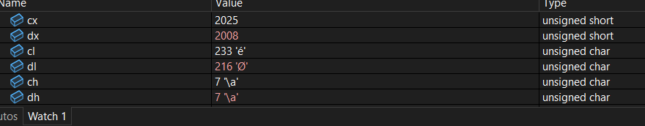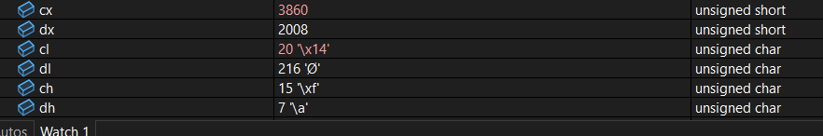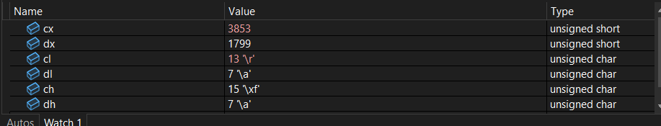

**RESULT**

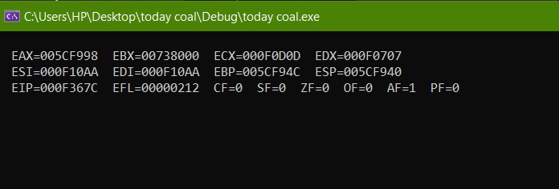

**Task 4**

INCLUDE Irvine32.inc

.code

main PROC

mov ax, 2025

mov bl, 28

add ax,bl

call DumpRegs

exit

main ENDP

END main

**The numbers addition shown error because different types**



**Task 5**

INCLUDE Irvine32.inc

.code

main PROC

mov ax, 225h

mov bx, 101000100001b

add ax,bx

call DumpRegs

exit

main ENDP

END main

**The numbers shown in red are the ones that have just changed because of the last instruction.**

**Like ax in first then bx**

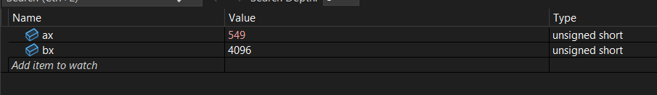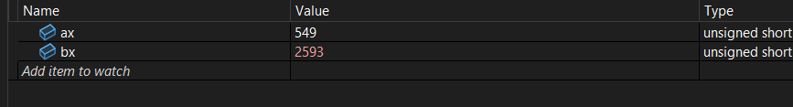

**RESULT**

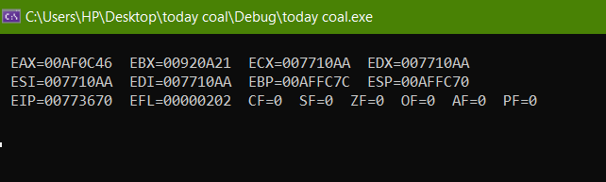

**Task 6**

INCLUDE Irvine32.inc

.code

main PROC

mov ax, 225h

mov bx, 04716q

add ax,bx

call DumpRegs

exit

main ENDP

END main

**The numbers shown in red are the ones that have just changed because of the last instruction.**

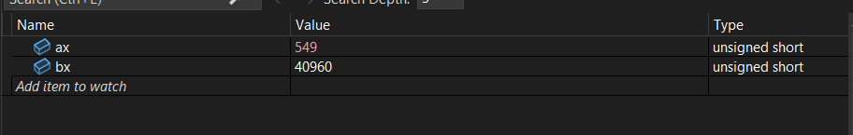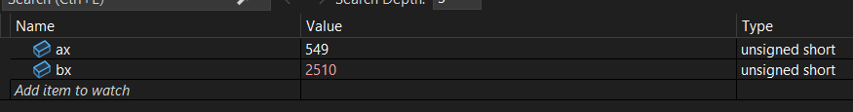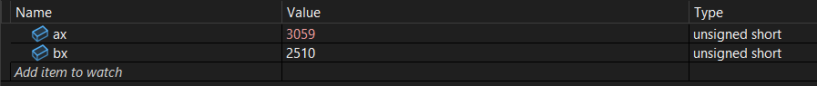

**RESULT**

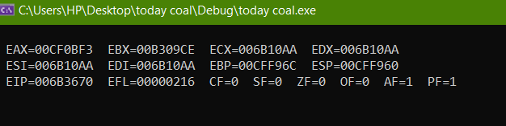

**Task 7**

INCLUDE Irvine32.inc

.code

main PROC

mov ax, 22Ah

mov bx, 716q

add ax,bx

call DumpRegs

exit

main ENDP

END main

**The numbers shown in red are the ones that have just changed because of the last instruction.**

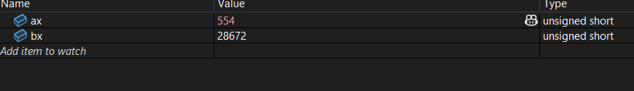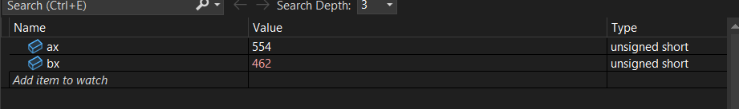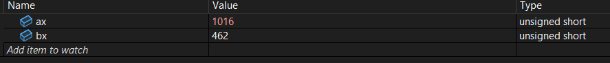

**RESULT**

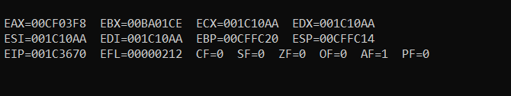

TASK 8

INCLUDE Irvine32.inc

.data

val1 DW 10

val2 DW 2000

val3 DW 30000

.code

main PROC

mov ax, val1

mov bx, val2

mov cx, val3

mov dx, ax

add ax, bx

add cx, ax

sub dx, bx

sub dx, cx

mul bx

mul cx

call DumpRegs

exit

main ENDP

END main

**The numbers shown in red are the ones that have just changed because of the last instruction.**

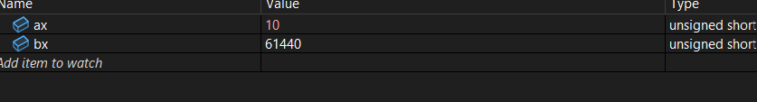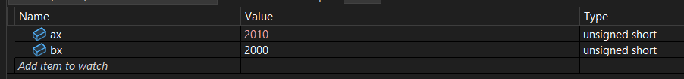

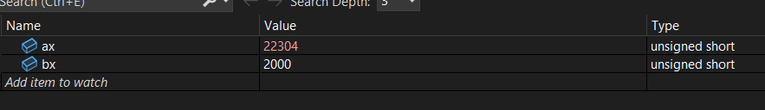

**RESULT**

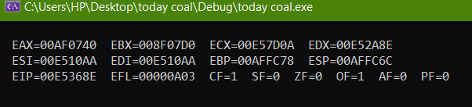

TASK 9

INCLUDE Irvine32.inc

.data

charac BYTE 'F'

.code

main PROC

mov al, charac

inc al

call DumpRegs

exit

main ENDP

END main

**The numbers shown in red are the ones that have just changed because of the last instruction.**

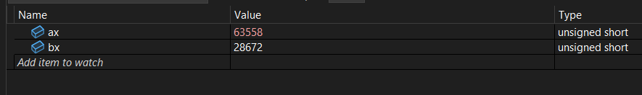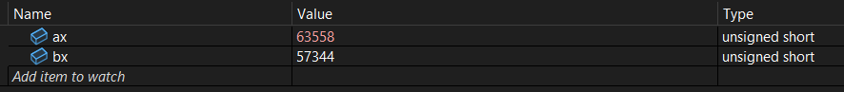

**RESULT**

